https://www.ti.com/lit/ug/tiduda1a/tiduda1a.pdf

- isolate components more expensive than non-isolated
- MCU on high voltage side, actual high voltage components isolated???

- 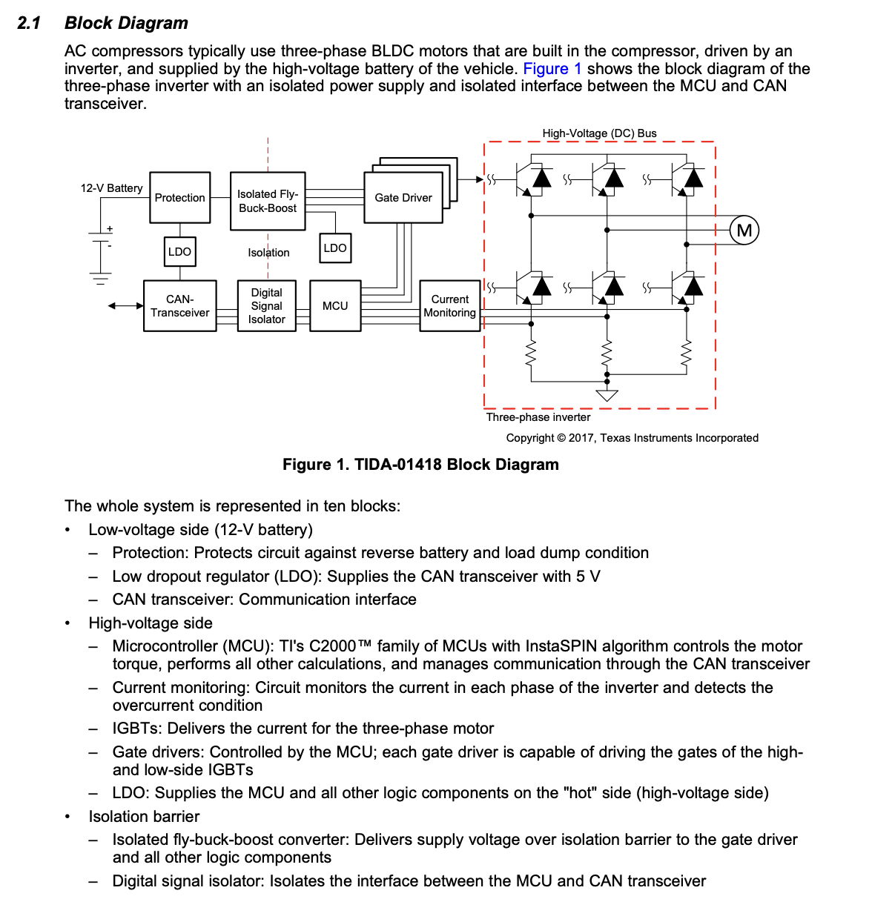

- Monitoring the OPA365-Q1 output with an ADC from the MCU is not sufficient for detecting the shortcircuit current and overcurrent in the inverter as fast as possible ……

